# Aetna Compass - Handling Compound Calls – Care

Compound Pharmacy to Fill for Members

Compound Prescription Already Filled

New Compound Prescription

Viewing Submission Clarification Code

Topical Analgesics and Compound Rejections

Bio-Identical Hormone / Thyroid Compounds

New Compound Language Template

Compounding Notification Letter Template

Abbreviations / Definitions

Related Documents

**Description:** Procedures when a caller has questions about Compounding medications to be filled at Retail (Point of Sale – POS) and Paper Claims. It addresses the following scenarios:

* If a **member calls** about coverage for a new compound prescription, refer to New Compound Prescription.
* If a **member calls** about a compound prescription that is on file, refer to Compound Prescription Already Filled.
* If the **pharmacy calls**, advise them to submit the compound prescription electronically, and then refer to the Compound Prescription Already Filled section below.

  Mail Order does **not** offer compounds.

**Note:** CCRs should verify the plan sponsor renewal date prior to entering authorization or providing information.

|  |
| --- |
| Compound Pharmacy to Fill for Members |

Icon - Important Information

* Mail Order pharmacies stopped filling compound prescriptions as of 03/01/2019.
* **Do not run** Test claims to determine compound prescription coverage since they require more than one ingredient. The Test Claim functionality allows pricing on a single ingredient. We are unable to provide pricing information to our members about compound medication.
* Retail pharmacy can process the claim with submission clarification code (SCC) of 8.

For Mail Order Compounding, the following compounding pharmacy fills for members:

**Note:** Contact the Compound Pharmacy for drug cost information.

|  |  |
| --- | --- |
| **Pharmacy** | **Location(s)** |
| **Millers of Wyckoff**  678 Wyckoff Avenue  Wyckoff, NJ  07481  **1-(201) 891-3333** | Ships to all 50 states and Washington D.C. and is USP 800 compliant.  **Compounds filled**: Capsules, gels, ointments, creams, pastes, suppositories, troches, liquids including hazardous compounds.  Icon - Important Information **No** injections of any type are filled. |

Top of the Document

|  |
| --- |
| Compound Prescription Already Filled |

If receive a call about a compound that has been filled and submitted under the new D.0 claim submission format, follow these steps:

|  |  |  |
| --- | --- | --- |
| **Step** | **Action** | |
| **1** | Determine if the Compound prescription was processed through the member’s prescription plan.  **Notes:**   * The phrase “DO NOT USE” may display in place of a medication name. This may require a call to the pharmacy or reviewing the **Compound** hyperlink as identified in Step 2. Standard drug names may not display. Ask for the date of fill and which pharmacy was used. * If the member intends to use Coordination of Benefits (COB) to cover a compound medication, they must submit the claim via Paper Claim. | |
| **If…** | **Then…** |
| Yes | From the Claims Landing Page, on the **Claims** tab locate the claim in question, then click the **Rx #** hyperlink.    **Result:** The Claim Details screen displays. Proceed to Step 2. |
| No | Advise the member that the pharmacy should submit the Compound prescription electronically.   * If this is not an option, determine if the client allows Paper Claims. * A [Compound Prescriptions Paper Claim Form (65609)](https://thesource.cvshealth.com/nuxeo/thesource/#!/view?docid=4551aa74-d56c-4466-89ae-1d2d4ffd9366) will be needed, which can be ordered via Fulfillment Support Task. Refer to [Compass - Paper Claim Multi-Ingredient Compound Prescription (58046)](https://thesource.cvshealth.com/nuxeo/thesource/" \l "!/view?docid=c5e05bf4-e050-4efc-a8df-6e1d51c513f0).   Do not run Test Claims to determine compound prescription coverage as they require more than one ingredient, and Test Claim functionality only allows pricing on a single ingredient.  **Note:** Members submits Compound Paper Claim forms to:  Government plans:   * Government Address:   <PBM Name>  P. O. Box 52195  Phoenix, AZ 85072-2195  Commercial plans:   * CVS/Caremark   P.O. Box 52136  Phoenix, AZ 85072-2136  Review the CIF to ensure CVS Caremark handles the plan’s paper claims. If not, advise member to send to the address provided in CIF. |
| **2** | On the Prescription Details screen for the Rx in question, locate Compoundthen click the **Yes** hyperlink.    **Result:** The Compound Details window displays. | |
| **3** | Review the Status and the Ingredient Cost (allowed cost) of each ingredient.    **Note:** If an Override/PA was applied, it is displayed in the Override/PA field. Commercial clients may choose to allow OTC ingredients within a Compound claim to be covered. | |
| **If the Status is…** | **Then…** |
| Accepted | The ingredient is covered. The Ingredient Cost indicates the amount reimbursable to the pharmacy (allowed cost). |
| Denied | The ingredient is not covered. The Ingredient Cost is displayed as $0.00.   * The cost of that ingredient is not factored into the member’s copay, and it is at the discretion of the pharmacy whether to charge the member the out-of-pocket cost for the non-covered ingredient.   + If the pharmacy needs assistance in bypassing non-covered ingredients, direct them to the Pharmacy Help Desk. * To view the settlement codes explaining the rejection, click the **Denied** hyperlink in the Status field. |
| **4** | Return to the Claim Details screen and click the **Financials Details** tab. Explain the member’s copay based on the information within the screen and the Accepted/Denied status within the previous Compound Details screen.  **Note:** Although each ingredient is adjudicated separately, they are added together to calculate the member’s copay.    **Example:** If a Compound contains three ingredients, each approved at $10 dollars, the total ingredient cost would be $30. A member with a flat copay of $5 would only be charged $5 copay. A member with a percentage copay of 20% would be charged $6.  **Note:** The pharmacy may include a **Level of Effort Fee** along with the ingredient costs and other charges. The Level of Effort is determined by the complexity of decision-making or resources utilized by a pharmacist to perform a professional service. This fee is factored into the total cost the pharmacy submits for reimbursement.  **Example from Financial Details Screen** | |

Top of the Document

|  |
| --- |
| New Compound Prescription |

If receive a call about determining coverage for a new Compound prescription, follow these steps:

|  |  |  |  |  |  |
| --- | --- | --- | --- | --- | --- |
| **Step** | **Action** | | | | |
| **1** | Review the CIF to determine if Compounds are not covered.   * If it advises Compounds are not covered, advise the member. * If it does not discuss Compounds, proceed to the next step.   **Note:** If any of the ingredients listed in the Bio-Identical Hormone / Thyroid Compounds section below are an ingredient in the compound, then it is considered an HRT medication. | | | | |
| **If...** | | **Then...** | | |
| Bio-Identical Hormone or Thyroid Compound (used for HRT) | | Review the “Need to Know” section of the CIF and the Benefit Details screen in ASD or HRP for comments specific to Bio Identical Hormone or Thyroid Compounds used for Hormone Replacement Therapy medications.  If no comments are displayed, the member does **not** have coverage for these types of compounded medications.  **Example:** | | |
| **If...** | **Then...** | |
| Yes | Proceed to Step 2. | |
| No  **Note:** **Please ensure the pharmacy processed with submission clarification code (SCC) of 8.** This will ensure it is a true rejection of ingredients/claim | 1. Advise the caller the compound is not covered under the plan. 2. Advise that you can initiate a Prior Authorization request on their behalf. If the request is denied, they will have the right to request an appeal. 3. Proceed to the appropriate work instruction:    1. Commercial members: [Aetna Compass - Handling Prior Authorization (PA) and Formulary Exception Requests (Electronic Prior Authorization / ePA) (064313)](https://thesource.cvshealth.com/nuxeo/thesource/#!/view?docid=31b425fd-efa4-4253-b6ba-f53513f84abe)    2. Medicare members: [Aetna Compass Med D - Handling Prior Authorization Inquiries (065603)](https://thesource.cvshealth.com/nuxeo/thesource/#!/view?docid=096dcedb-fa61-418c-86cd-aa470ca83b02) | |
| Bulk Powder  **(Commercial SI plans only)** | | Review the “Need to Know” section of the CIF and the Benefit Details screen in ASD for comments specific to Bulk powders.  If no comments are displayed, the member does **not** have coverage for these types of compounded medications.  **Note: Because Bulk powder compounds are not FDA approved:**   * Commercial Self-Insured (SI) plans only cover Bulk powders if their plan sponsor opts to approve coverage. * Commercial Fully Insured plans do NOT cover Bulk powders * Medicare plans do NOT cover Bulk powders.   **Example:** | | |
| **If...** | | **Then...** |
| Yes | | Proceed to Step 2. |
| No  **Note:** **Please ensure the pharmacy processed with submission clarification code (SCC) of 8.** This will ensure it is a true rejection of ingredients/claim | | 1. Advise the caller the compound is not covered under the plan. 2. Advise that you can initiate a Prior Authorization request on their behalf. If the request is denied, they will have the right to request an appeal. 3. Proceed to Step 5 of the “Member OR Pharmacy Is Requesting a Prior Authorization” section in [Aetna Compass - Handling Prior Authorization (PA) and Formulary Exception Requests (Electronic Prior Authorization / ePA) (064313)](https://thesource.cvshealth.com/nuxeo/thesource/#!/view?docid=31b425fd-efa4-4253-b6ba-f53513f84abe). |
| Any other compound | | Review the “Need to Know” section of the CIF and the Benefit Details screen in ASD or HRP to determine if compounds in general are covered. | | |
| **If...** | | **Then...** |
| No comments are displayed in either the CIF, ASD, or HRP | | 1. Educate the caller that the compounded medication can possibly be covered, depending on if the ingredients themselves are covered in the quantities that are needed. 2. Proceed to Step 2. |
| Comments indicate that compounds in general are not covered | | 1. Advise the caller the compound is not covered under the plan. 2. Answer any additional questions according to regular call handling guidelines. |
| **2** | Determine if the member wants to fill the prescription at their retail pharmacy who Compounds medications. | | | | |
| **If…** | **Then…** | | | |
| No | Would they like us to refer them to a Compounding pharmacy?   * If yes, refer to the Compound Pharmacy to Fill for Members section. * If no, no further action is needed. | | | |
| Yes | Advise the member to contact their Retail pharmacy to determine if they will be able to make the compound, then proceed to the next step.  **Notes:**   * If the member intends to use a Coordination of Benefits to cover a Compound medication, they must submit the claim via a Paper Claim. * For additional information, refer to [Aetna Compass – Viewing Coordination of Benefits (COB) and Manufacturer Copay Assistance Card (065855)](https://thesource.cvshealth.com/nuxeo/thesource/#!/view?docid=8ea418e6-1c80-4f19-a23b-3dec9eded42c) or [Compass - Paper Claim Multi-Ingredient Compound Prescription (58046)](https://thesource.cvshealth.com/nuxeo/thesource/#!/view?docid=c5e05bf4-e050-4efc-a8df-6e1d51c513f0). | | | |
| **3** | Inform the member that the price of the compound is available once submitted through their insurance. Due to the complexity of Compounds, it is not possible to provide an accurate price quote in advance.  Encourage the member to ask the pharmacy to submit the claim to their insurance first before creating the compound. This gives them the opportunity to decline if unwilling to pay for the cost of the compound. | | | | |

Top of the Document

|  |
| --- |
| **Viewing Submission Clarification Code** |

If you need to ensure that the Retail pharmacy processed a compound ingredient with the submission clarification code (SCC) of 8, follow these steps:

|  |  |
| --- | --- |
| **Step** | **Action** |
| **1** | Access the member account in Compass. |
| **2** | Click the **Prescription number** hyperlink for the claim in question. |
| **3** | Click the **Transmission** **Detail** tab. |
| **4** | Review the **Other** Section under the **Transmission IN**. The Submission Clarification Code should display in the **Denial Clarification Code** field. |

Top of the Document

|  |
| --- |
| Topical Analgesics and Compound Rejections |

**Icon - Important Information** Does not apply to Medicare Part D, Medicaid, EGWP Wrap or Marketplace (Exchange) plans.

Non-FDA approved topical analgesic pain patches may reject NDC/Plan Exclusion for commercial plans if they contain the ingredients, but are not limited to Lidocaine, Menthol, Capsaicin and Methyl Salicylate.

Prior Authorization may be required for compound drug claims over $300 (no fill limit), as well as the exclusion of costly Compounding bases and bulk Compounding powders and Compound kits.

|  |  |  |
| --- | --- | --- |
| **If the Prescription is a…** | **And Rejects…** | **Then…** |
| Topical Analgesic | NDC Not Covered/Plan Exclusion | Your plan now excludes topical analgesics medication. These products are not FDA approved, and there is no clinical data to determine if they are safe and effective. Very often an FDA approved alternative is available so discuss with your physician if a commercially available product is appropriate to treat your condition. |
| Topical Analgesic | PA Required | Ask your doctor to call us toll-free at 1-800-294-5979 to request prior authorization. |
| Compound Drug | NDC Not Covered/Plan Exclusion | Your plan now excludes all bulk compounding powders and (in some cases) certain compound bases. These products are not FDA approved, and there is no clinical data to determine if they are safe and effective. Very often an FDA approved alternative is available that does not require compounding. Discuss with your physician if a commercially available product is appropriate to treat your condition. |

Top of the Document

|  |
| --- |
| Bio-Identical Hormone / Thyroid Compounds |

If any of the ingredients listed below are an ingredient in the compound, then it is considered a Hormone Replacement Therapy (HRT) medication.

Review the “Need to Know” section of the CIF and the Benefit Details screen in ASD or HRP for any exceptions. If no comments are displayed, the member does **not** have coverage for these types of compounded medications.

|  |  |
| --- | --- |
| Bi-Est capsule/cream/in oil/troche | Progesterone hrt cream/capsule |
| Bi-Est with Progesterone and Testosterone capsule/cream | Progesterone/DHEA |
| Bi-Est with Progesterone capsule/cream | Testosterone capsule/cream/ gel/ in oil/ patch/SL drop/troche |
| Bi-Est with Testosterone capsule/cream | testosterone/chrysin |
| Estradiol cream/suppository | Tri-Est capsule/cream/Sublingual/troche/ |
| Estriol capsule/cream/suppository | Tri-Est with progesterone and testosterone capsule/troche/cream |
| Estriol with progesterone and testosterone capsule | Tri-Est with progesterone capsule/cream/ troche |
| Estriol with testosterone capsule | Tri-Est with testosterone capsule/cream/ troche |
| Estrogen cream/in oil/suppository | Levothyroxine (T4) tab/cap |
| Estrogen with progesterone and testosterone cream/troche | liothyronine cap/tab |
| Estrogen with progesterone cream/in oil | T3 |
| Estrogen w/testosterone cream/troche | T3/T4 |
| Progesterone cream (equiv to crinone) hrt | Tri-Iodothyronine (liothyronine; T3, Levothyroxine T4) |
| Progesterone with testosterone in oil/ capsule/cream/ troche |  |

Top of the Document

|  |
| --- |
| New Compound Language Template |

Refer to as needed:

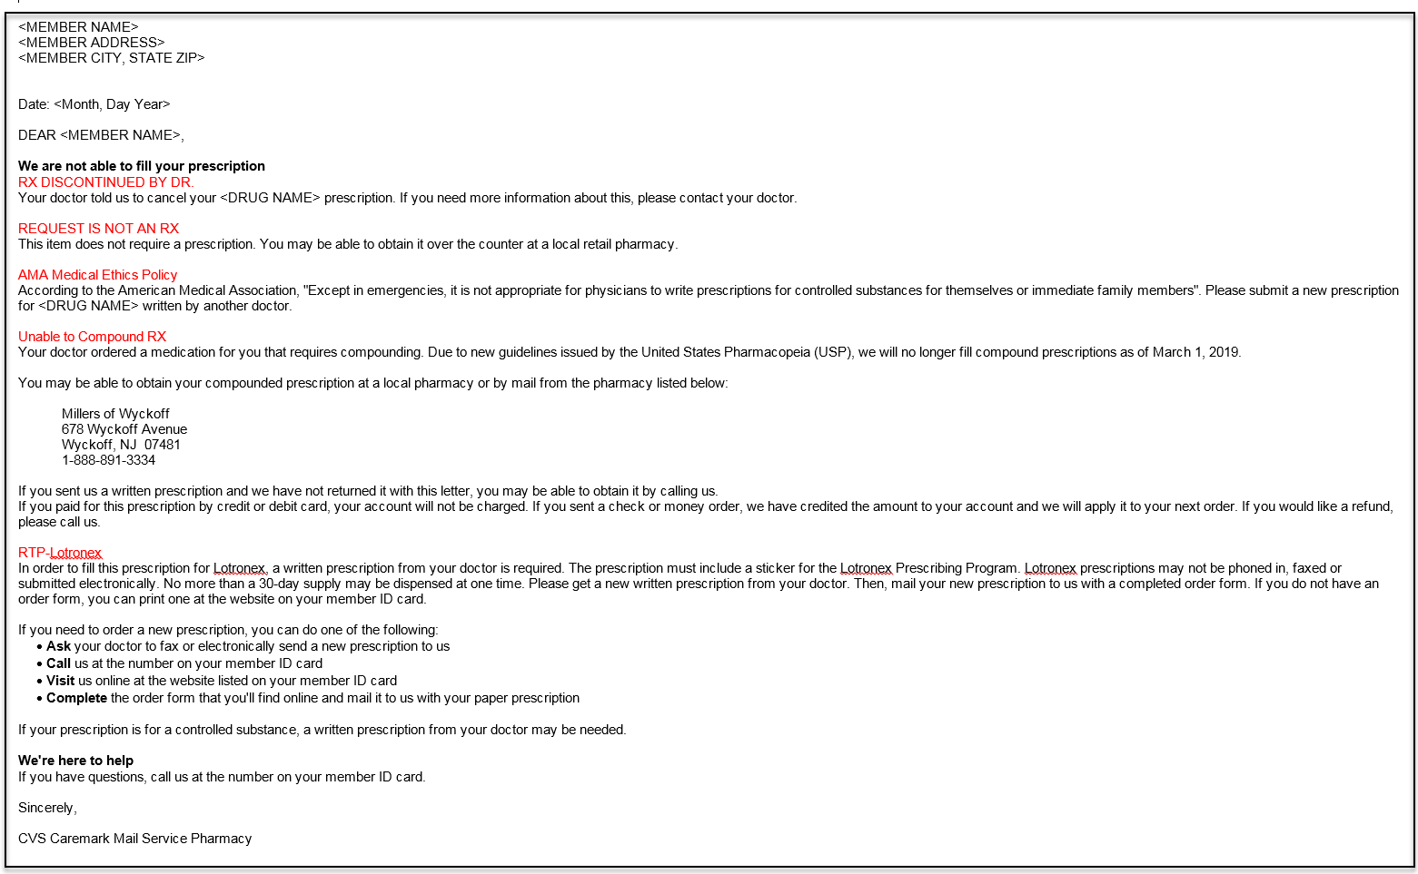

Top of the Document

|  |
| --- |
| Compounding Notification Letter Template |

This letter template is used for notifying members that they can obtain their compound prescription through the Millers of Wyckoff pharmacy:

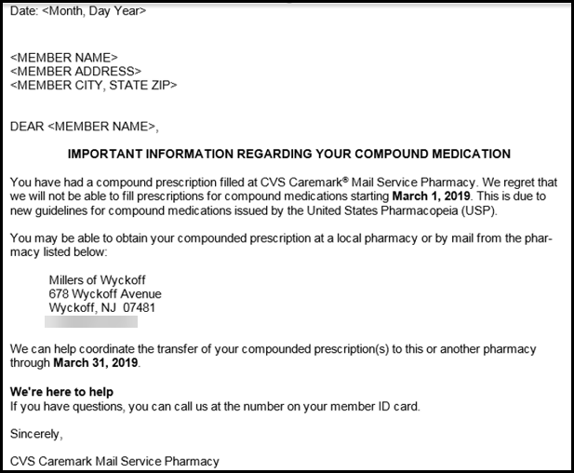

Top of the Document

|  |
| --- |
| Abbreviations / Definitions |

|  |  |
| --- | --- |
| **Term** | **Definition** |
| **Compound** | Prescription compounding (done in compounding pharmacies) is the creation of a particular medication to fit the unique need of a patient. |
| **Hormone Replacement Therapy (HRT)** | Any form of hormone therapy wherein the patient, in the course of medical treatment, receives hormones, either to supplement a lack of naturally occurring hormones or to substitute other hormones for naturally occurring hormones. This may include the use of medications such as Bio-Identical Hormones or Thyroid Compounds. |

Top of the Document

|  |
| --- |
| Related Documents |

**Abbreviations / Definitions:** [Customer Care Abbreviations, Definitions, and Terms Index (17428)](https://thesource.cvshealth.com/nuxeo/thesource/#!/view?docid=c1f1028b-e42c-4b4f-a4cf-cc0b42c91606)

**Parent Document:** [CALL 0049 Customer Care Internal and External Call Handling](https://policy.corp.cvscaremark.com/pnp/faces/DocRenderer?documentId=CALL-0049)

Top of the Document

Not to Be Reproduced or Disclosed to Others without Prior Written Approval

**ELECTRONIC DATA = OFFICIAL VERSION / PAPER COPY = INFORMATIONAL ONLY**